Introduction

Overview:

While most Android users can access it easily through their phones, many iOS users have also downloaded the app for the briefing style. The app gives you briefs and latest news .

Purpose:

Headlines brings daily stories from around the World + US & UK: news, weather and sports on your mobile device with a clean, intuitive design - perfect for any news junkie.

Problem Definition And Design Thinking:

Empathy Map:

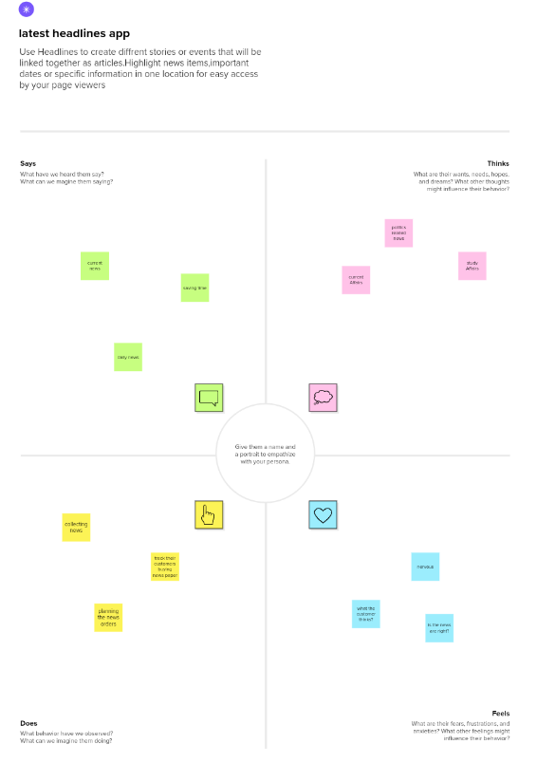

Ideation And Brainstorming Map:

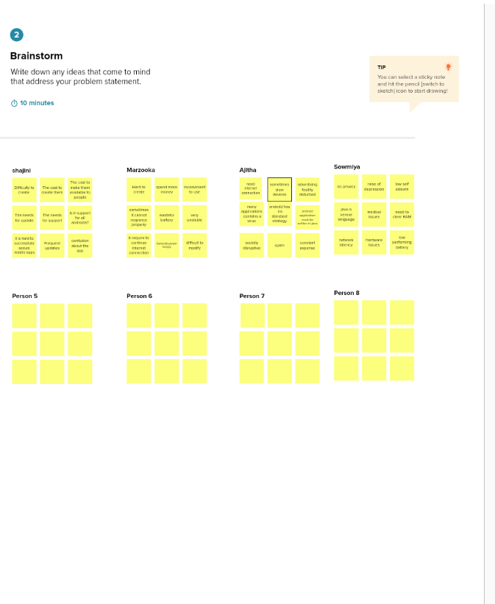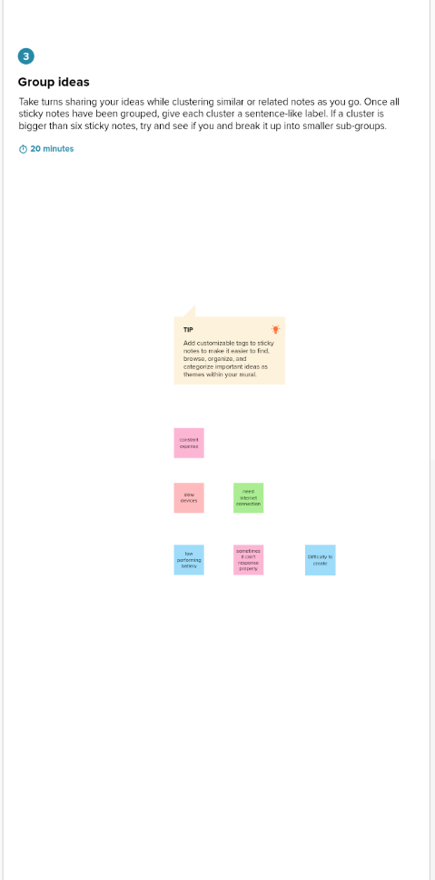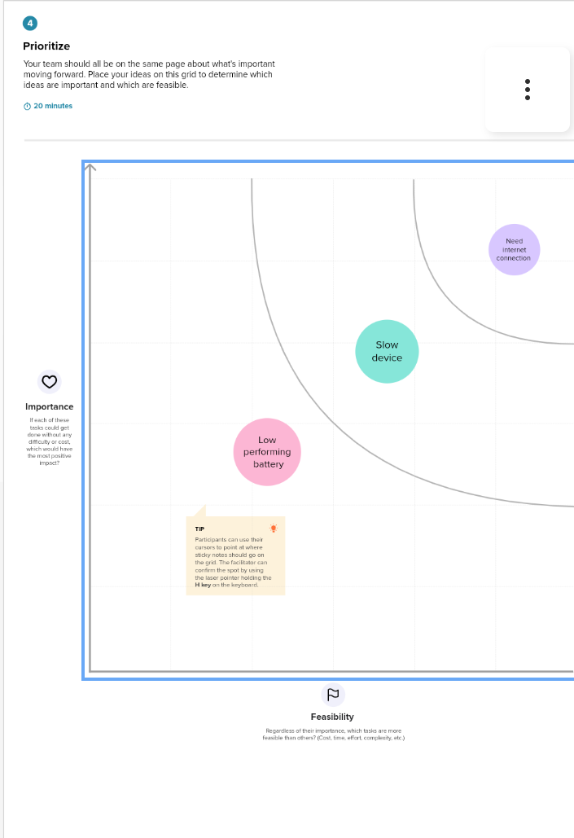

Result:

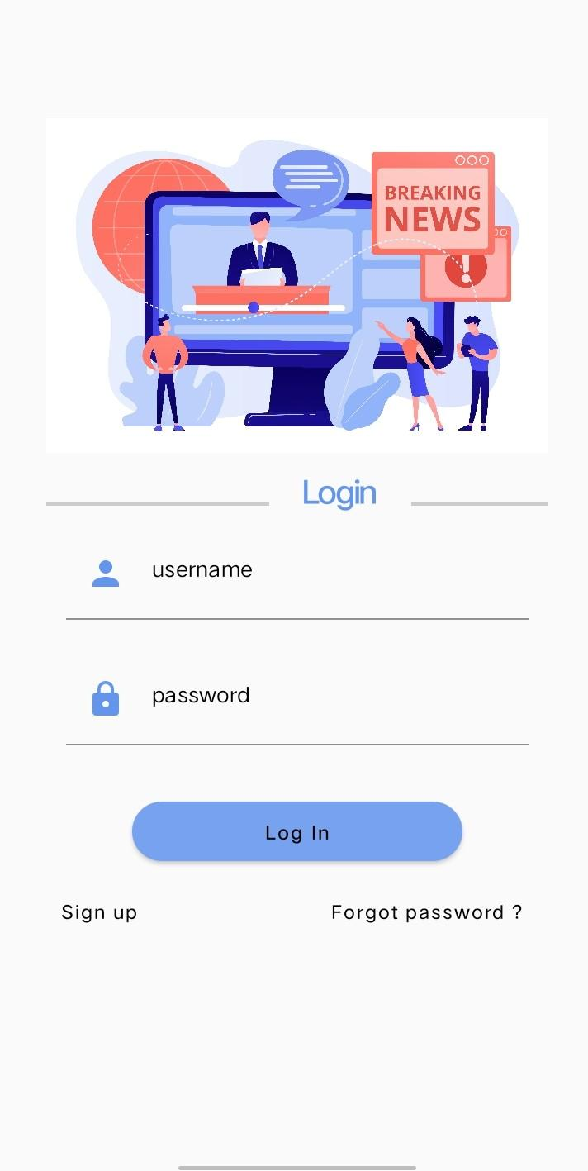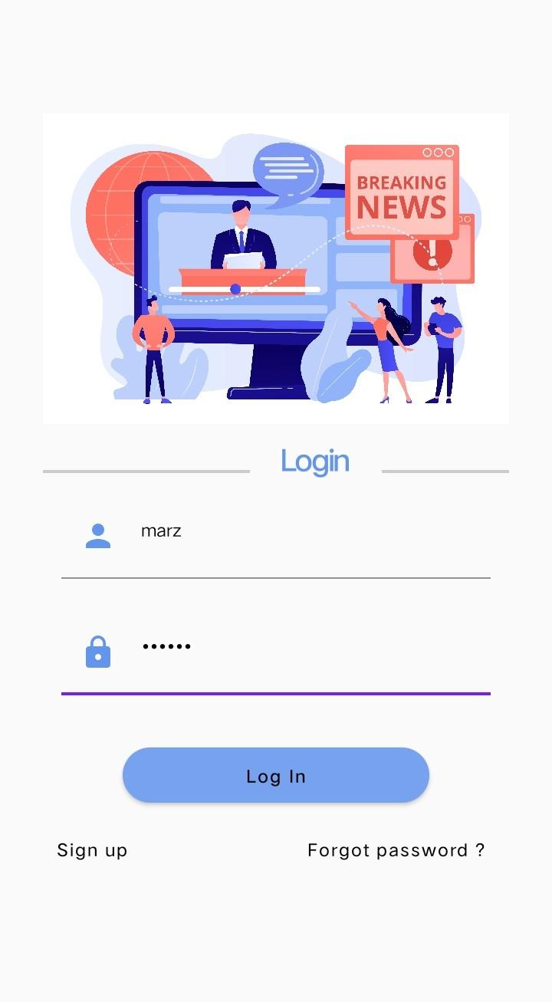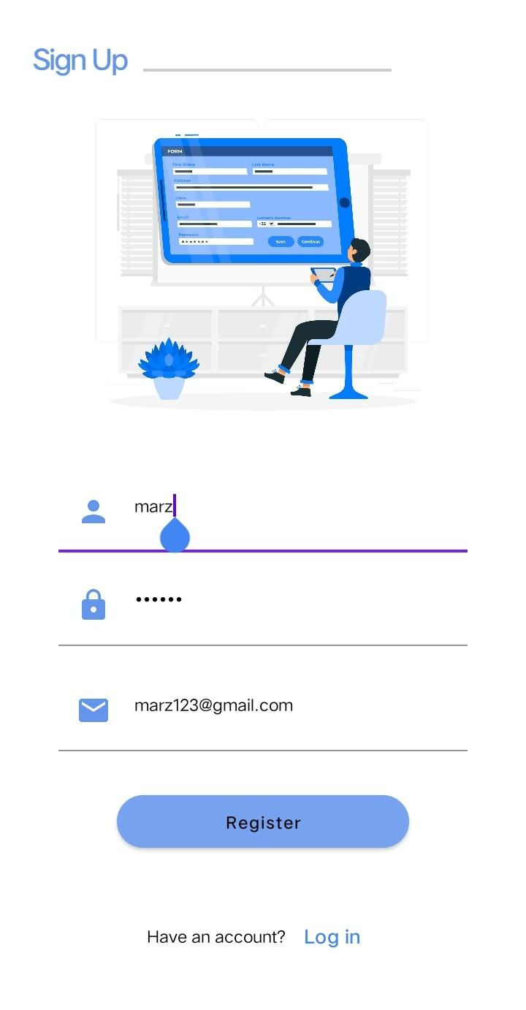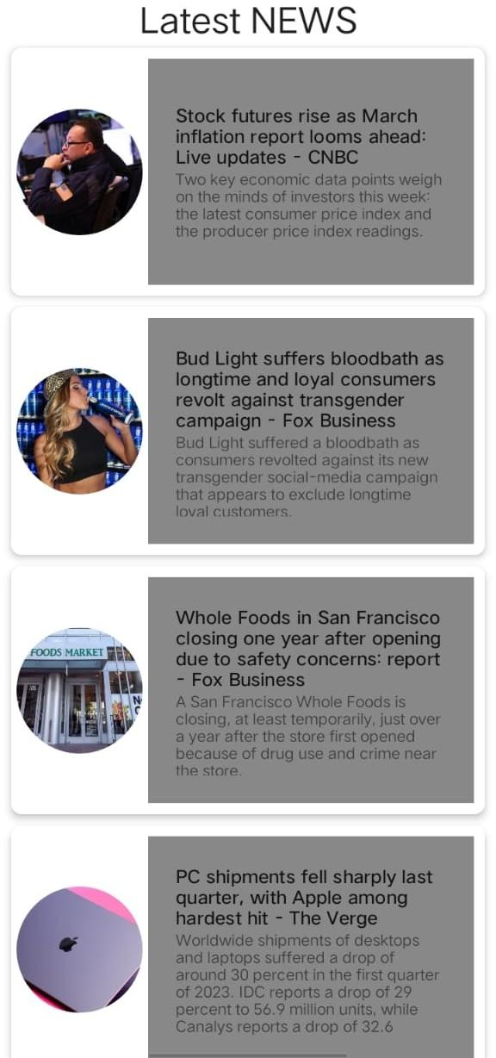

Advantages And Disadvantages:

advantages:

1.own your channels.

2.Better user experience.

3.Higher enhancement.

Disadvantages:

1.It can shortchange complex stories or avoid them together .

2.sometimes it will give fake News.

3.network connection is necessary.

Applications:

The main focus of this application is to connect news articles from all around the world and deliver it to user as fast as possible in best visualize way.

Conclusion:

This app is very useful to the people to know the latest news immediately and easily by their mobile phones.

Future Scope:

The future enhancement for this app are:

Capture and retain reader attention.

Pretty and straightforward.

Appendix:

Source code:

<?xml version="1.0" encoding="utf-8"?>

<manifest xmlns:android="http://schemas.android.com/apk/res/android"

xmlns:tools="http://schemas.android.com/tools">

<uses-permission android:name="android.permission.INTERNET"/>

<uses-permission android:name="android.permission.ACCESS_WIFI_STATE"/>

<application

android:allowBackup="true"

android:dataExtractionRules="@xml/data_extraction_rules"

android:fullBackupContent="@xml/backup_rules"

android:icon="@drawable/news_app_icon"

android:label="@string/app_name"

android:supportsRtl="true"

android:theme="@style/Theme.NewsHeadlines"

tools:targetApi="31">

<activity

android:name=".DisplayNews"

android:exported="false"

android:label="@string/title_activity_display_news"

android:theme="@style/Theme.NewsHeadlines" />

<activity

android:name=".RegistrationActivity"

android:exported="false"

android:label="@string/title_activity_registration"

android:theme="@style/Theme.NewsHeadlines" />

<activity

android:name=".MainPage"

android:exported="false"

android:label="@string/title_activity_main_page"

android:theme="@style/Theme.NewsHeadlines" />

<activity

android:name=".LoginActivity"

android:exported="true"

android:label="@string/app_name"

android:theme="@style/Theme.NewsHeadlines">

<intent-filter>

<action android:name="android.intent.action.MAIN" />

<category android:name="android.intent.category.LAUNCHER" />

</intent-filter>

</activity>

</application>

</manifest>